\begin{figure}[h]

\centering

\includegraphics[width=1\textwidth]{Images/Page de garde FSG.png}

\label{fig:pdg}

\end{figure}Z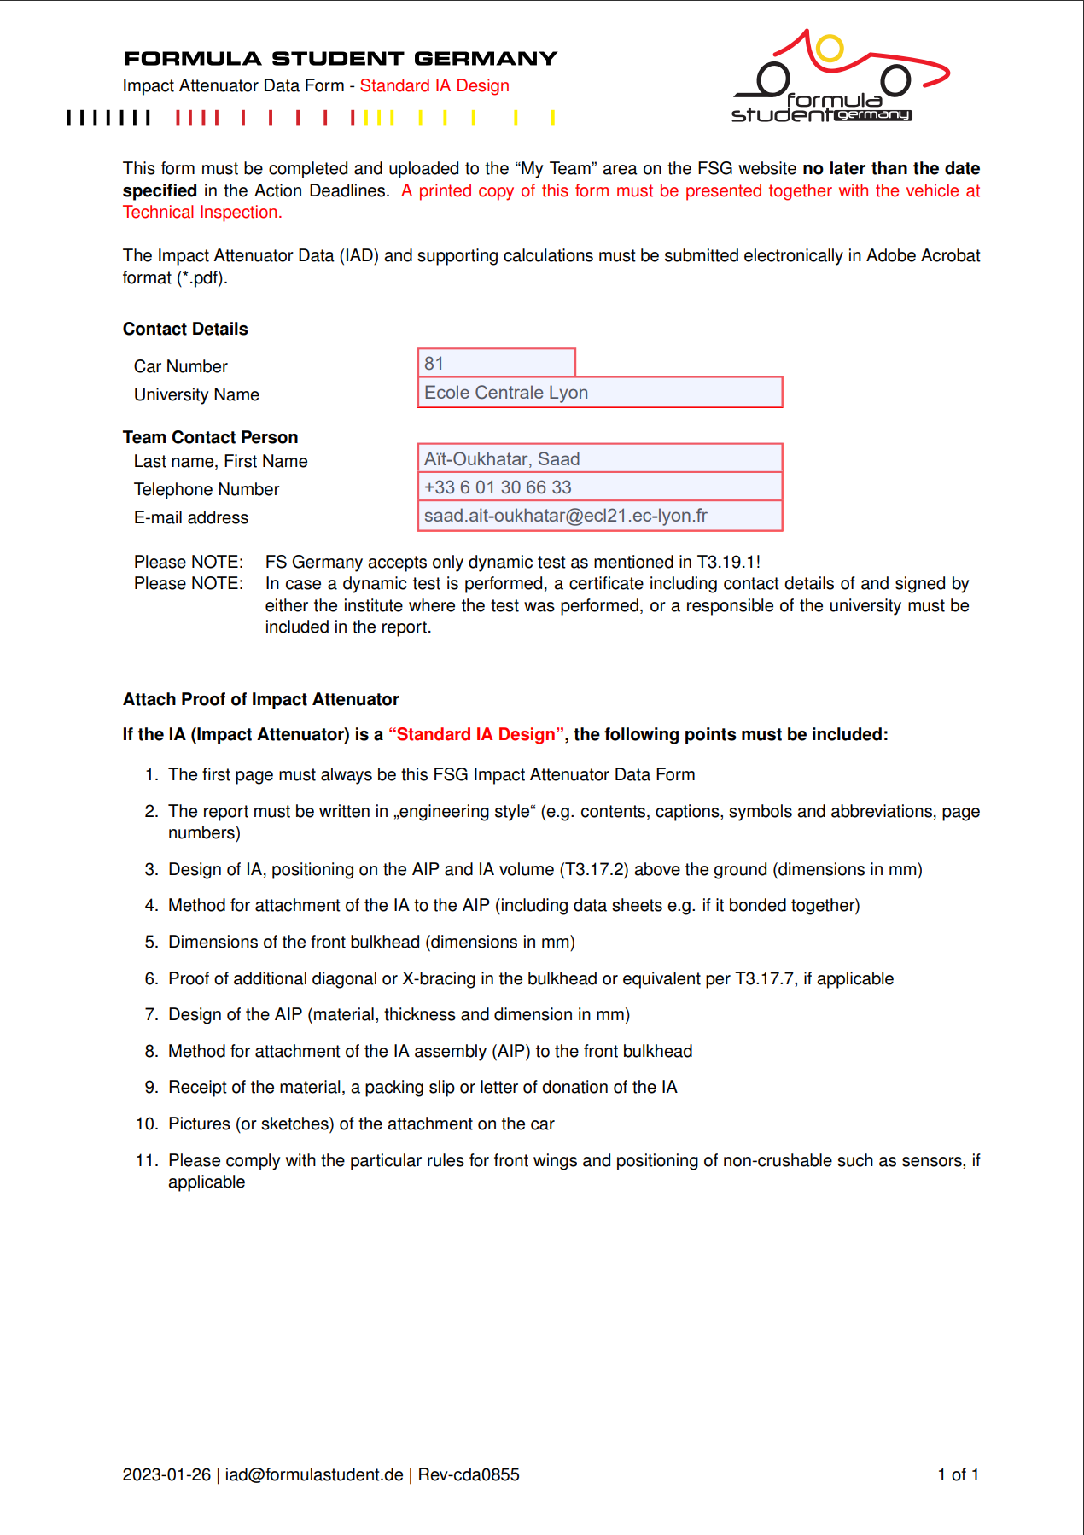

3. **Design of IA, positioning on the AIP and IA volume :**

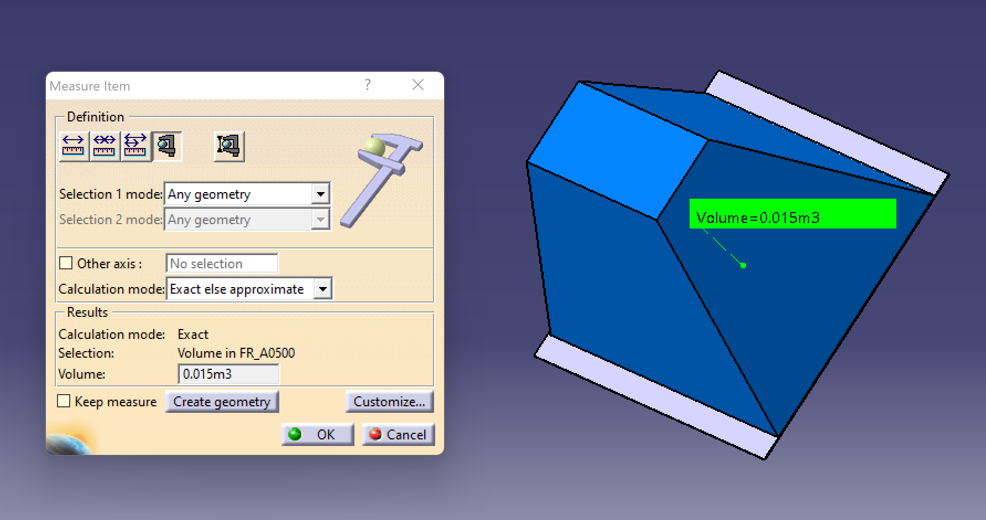

**4. Method for attachment of the IA to the AIP**

The Impact Attenuator is glued to the Anti-Intrusion plate. Here follows the data sheet of the glue used :

**5. & 6. Dimensions of the front bulkhead and proof of an additional diagonal :**

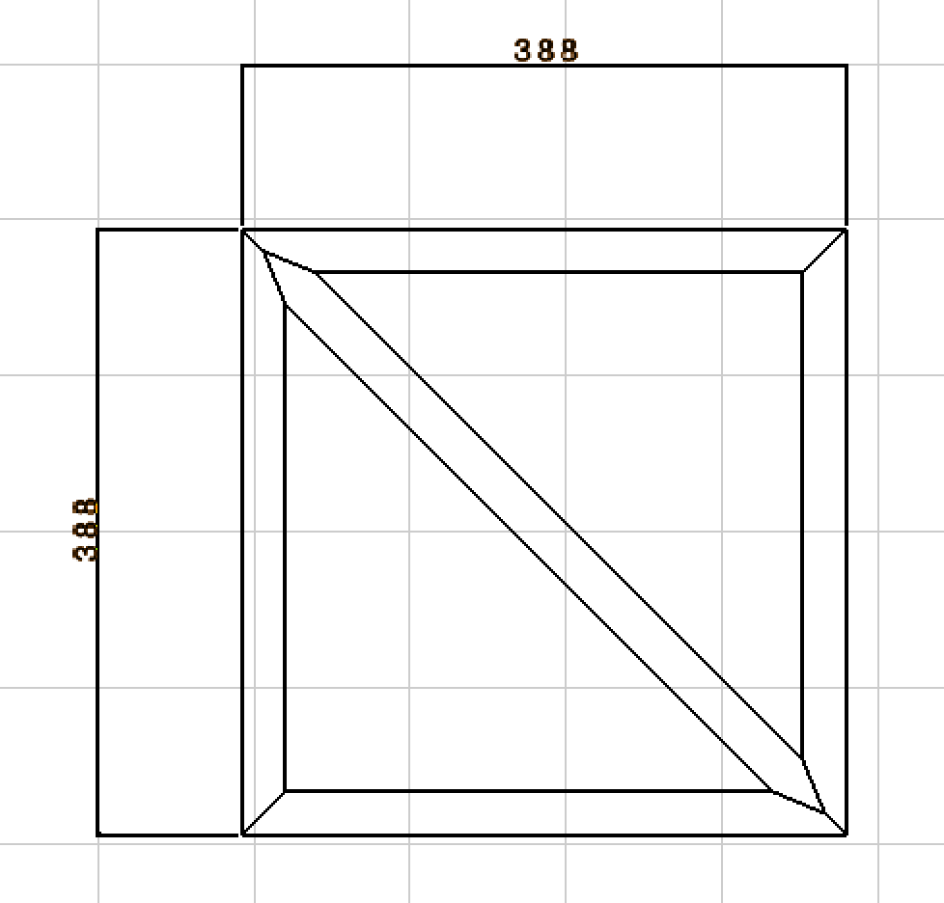

Tubes dimensions : 28 x 1.5

**7. Design of the AIP :**

**8.**

**9.**

**10.**